# OBSTACLE DETECTION IN VEHICLE

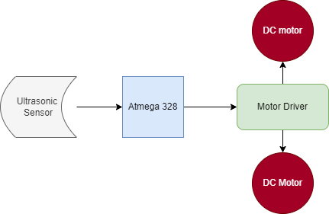

BLOCK DIAGRAM

ULTRASONIC SENSOR:

* It sends Ultrasonic Pulse through air and if any obstacles found the pulse hits and return back.
* By calculating the time taken to return the distance is measured.

ATMEGA 328:

* Single Chip Microcontroller in AVR Family.

MOTOR DRIVER:

* Interface between controller and motor.
* It takes low current control signal into higher current control signal that can drive a motor.

DC MOTOR:

* Converts electric energy in mechanical energy.